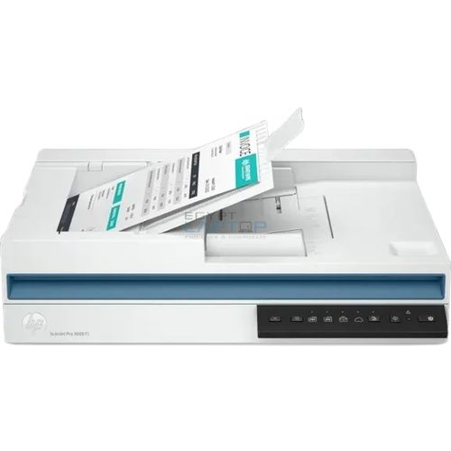
HP SCANER-HP-PRO 3600 F1
Scanning Speed | 18ppm
Technology | ReadyScan LED
Paper Capacity | 40 Pages
Build in | ADF
Power Consumption | Low

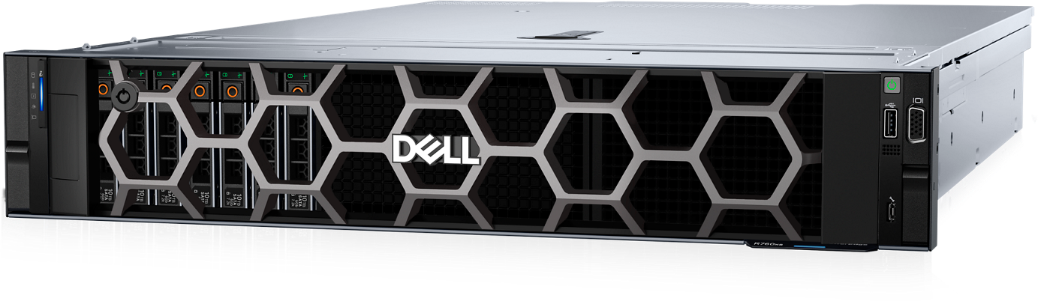
DELL PowerEdge R760xs (Dual Xeon Silver 4416+, 4x32GB, 3x960GB SSD)

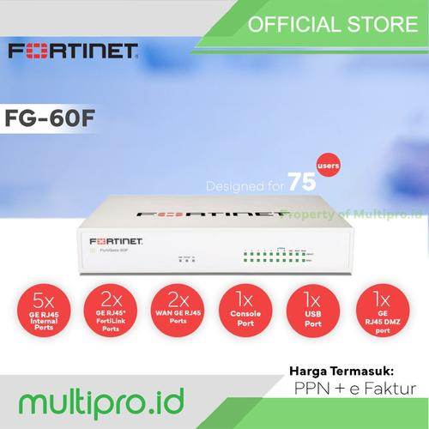
Fortinet Fortigate FG-60F (UTM Bundle License 24x7 and NBD-RMA)

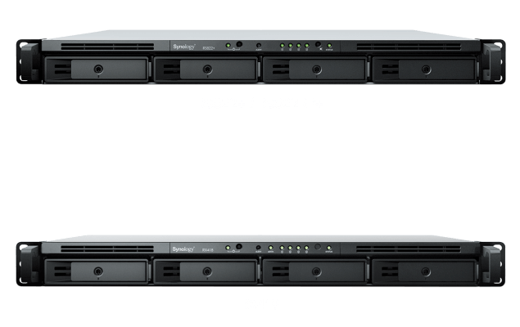
SYNOLOGY NAS RS822+ 2GB 1U - 4Bay, AMD Ryzen V1500B 2C/4T,2xGbE,USB+Ram 8GB

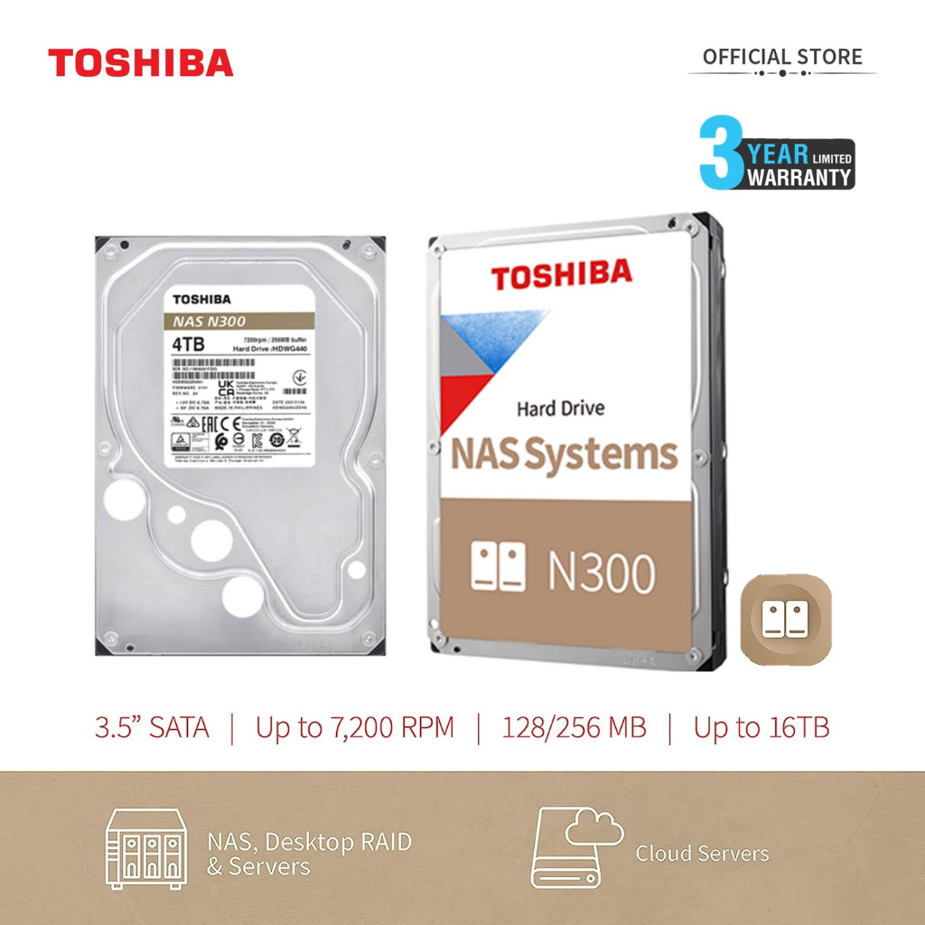
Toshiba N300 4TB 3.5" HDD/ HD/ Hardisk/ Harddisk Internal NAS 4 TB N 3

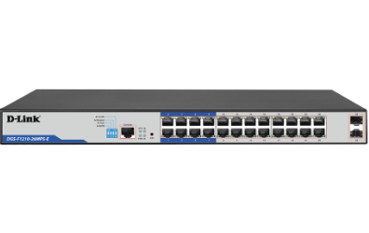D-LINK 26-Port Gigabit Smart Managed PoE Switch DGS-F1210-26PS-E

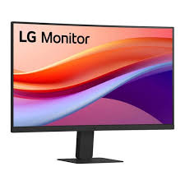 Monitor LG 24U421A LED 24 Inch VA 100Hz Curved HDMI USB type C.

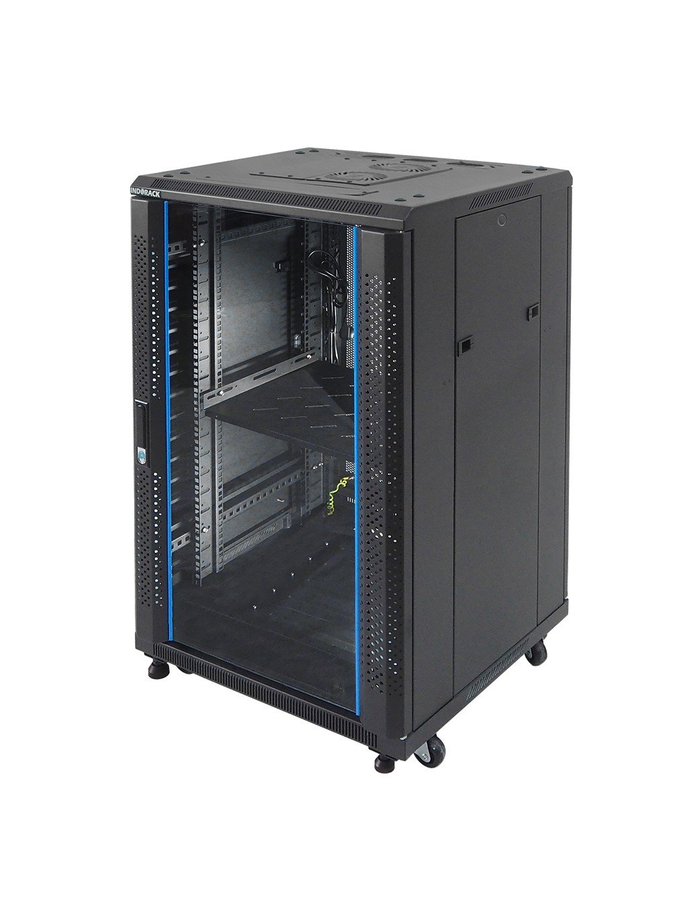Glass Door Rack server 20U Depth 600mm : IR6020G

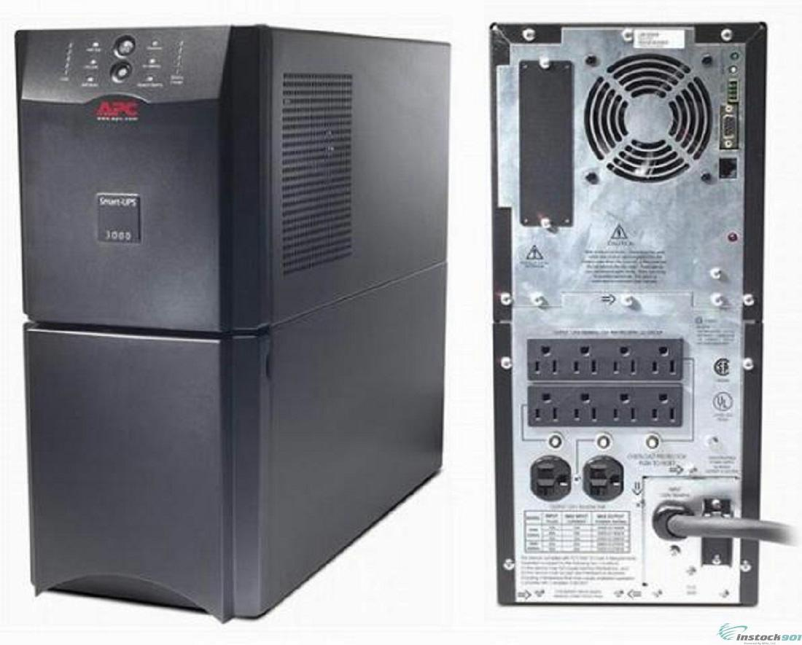
APC SUA 2200VA 1980W Modifikasi 48V

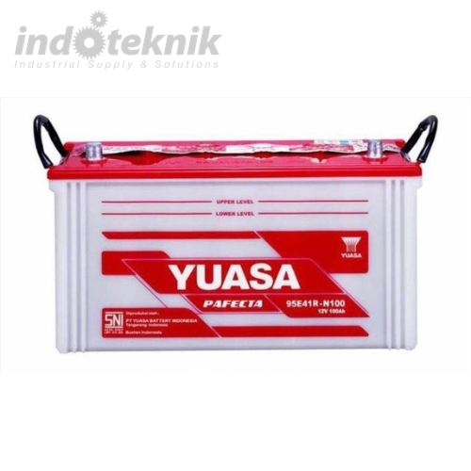
Baterai Accu 100AH

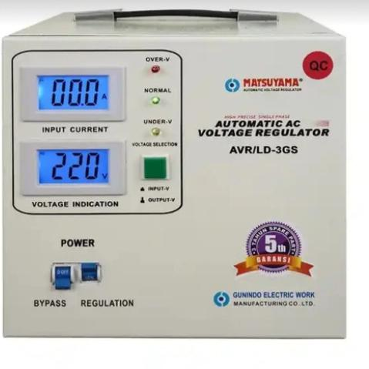
Stabilizer Stavol AVR MATSUYAMA Stavolt 3000 Watt 3kva AVR/LD-3GS

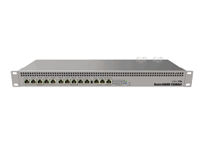
Mikrotik RB 1100 AHx4 RB1100

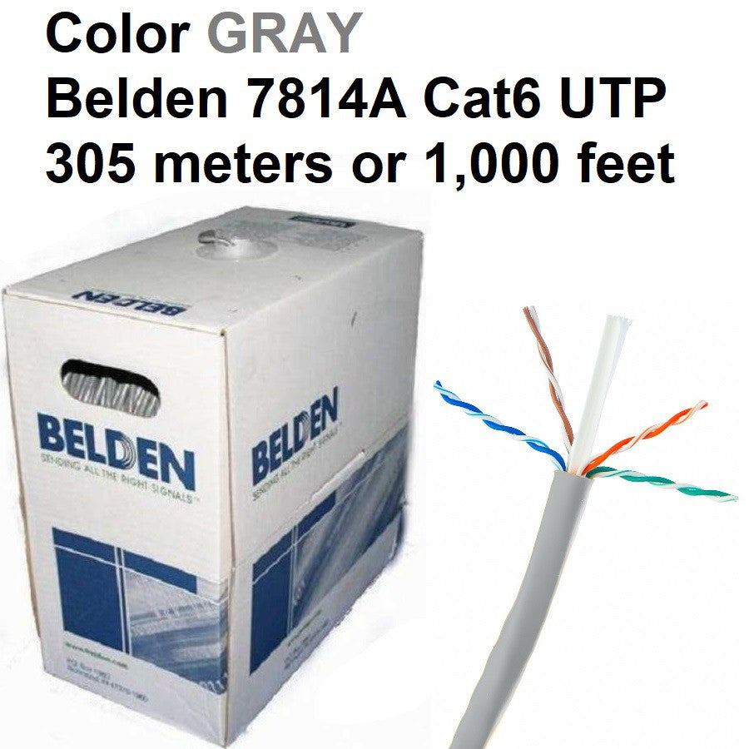

Cable UTP Cat6 (Belden)

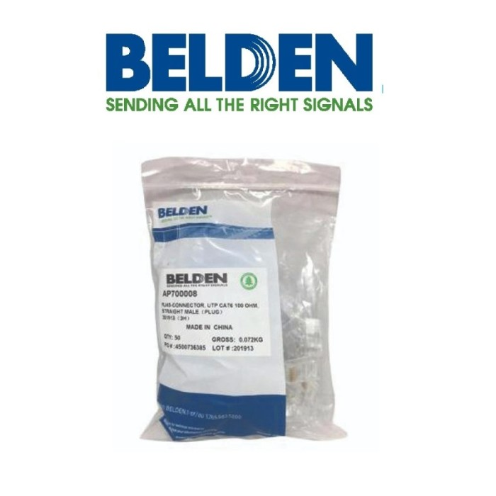
Connector RJ45 Belden

